README

Title: Display Metrics and Average Display Luminance (ADL)

Authors: Chloe Callahan-Flintoft1,2 and Chou P. Hung2

1 ORAU

2 US Army Research Laboratory

E-mail: Chou.p.hung.civ@mail.mil

INTENDED PURPOSE of the software:

This is custom Matlab code for measuring computer display metrics (e.g. for LCD monitors and HDR video projectors). It displays different patterns on the screen, so that a photometer can be used to measure deviations from expected luminance. The metrics supported include stray light, spatial uniformity, and spatial uniformity at high spatial frequency. The display image for stray light measurement consists of a white or black disk at 1, 2, or 4 degree diameter over a black background with white squares filling 0, 1, 2, 5, 10, 20, or 50% of the total background area (i.e. average display luminance, “ADL”). The spatial uniformity test is a white disk against a black background, or a black disk against a white background, at various horizontal and vertical offsets. The spatial uniformity at high spatial frequency test consists of a full-screen grating of thin white lines, vertical or horizontal, at 10 pixels per cycle and line thicknesses of 1, 2, 5, 8, 9, and 10 pixels. These tests are generally useful to the public, because today’s high-performance LCD and projector displays have dual-layer LCDs that produce spatial non-uniformities as a tradeoff for high luminance contrast ratio.

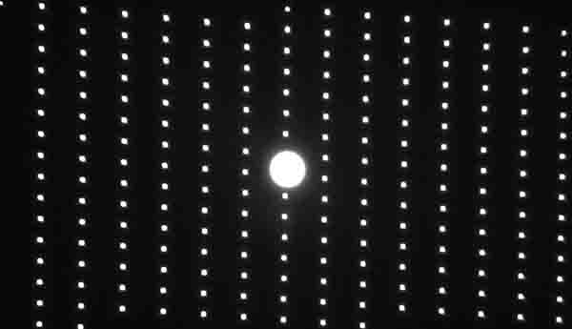 Example test images at 1 and 2% ADL

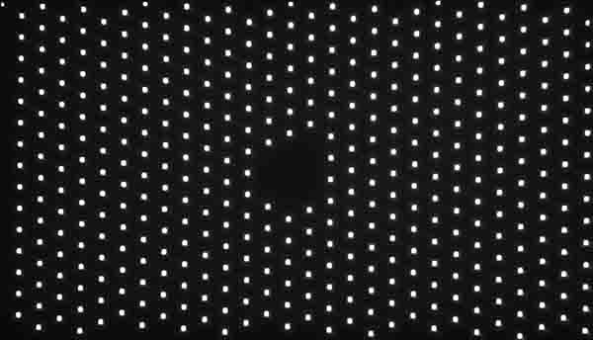

LICENSE: Apache 2.0

VERSION: 1.0

SYSTEM REQUIREMENTS:

MATLAB

Psychtoolbox 3.0

A computer display set to 1920x1080 pixel resolution

A quality spectrophotometer for making luminance measurements of the display

HOW TO USE:

1. Install Psychtoolbox 3.0, a free MATLAB package for psychophysics testing. <http://psychtoolbox.org/>
2. Extract the Display Metrics and Average Display Luminance (ADL) code, lumTestOSS.zip.
3. Type the following at the MATLAB command prompt:
   1. cd lumTestOSS
   2. Runexp(‘<filename without .m>’), e.g. Runexp(‘lumTest_checkers2aper’)

LIST OF CODES REQUIRING OSS REVIEW and APPROVAL:

The following lumTestOSS.zip code were written by CC-F and CPH and are in the folder /blocks:

1. lumTest.m
2. lumTest_checkers0per.m % displays a circular test patch against a black background
3. lumTest_checkers1per.m % displays a circular test patch against a 1 percent ADL background
4. lumTest_checkers2aper.m % 2 percent ADL
5. lumTest_checkers5bper.m % 5 percent ADL
6. lumTest_checkers10per.m % 10 percent ADL
7. lumTest_checkers20per.m % 20 percent ADL
8. lumTest_checkers50per.m % 50 percent ADL
9. lumTest_lines.m % displays horizontal and vertical lines at different black-to-white ratios, all at 10-line periodicity. The most interesting cases are at 1- and 2-white line thickness, which reveal the non-linear effect of double-layer LCD at eccentric view angles.

Note: Extracting lumTestOSS.zip code also extracts open source Matlab support functions ‘Stream’ written by Brad Wyble et al., namely Runexp.m in the main folder and many files in the subfolder /StreamCore. These support functions do not require OSS review and approval, because they are already open source under Gnu GPL 3.0 (<http://www.gnu.org/licenses/gpl-3.0.html>) and are also downloadable from <https://osf.io/tdvxm/> . The StreamCore files are included in this OSS release for convenience.